1. **In your own words, what is a subquery?**

A subquery is an inner query within an outer query. The inner query can be self-contained or correlated with the outer query.

1. **In your own words, what is a self contained subquery?**

Self-contained subqueries are subqueries that are independent of the outer query.

1. **In your own words, what is a correlated subquery?**

Correlated subqueries that refer to attributes from the tables that appear in the outer query.

1. **Give an example of a subquery that returns a single value. When would you use this kind of subquery?**

You would use this kind of subquery when you need one specific piece of information from a general query. This query will return the maximum order ID in the table.

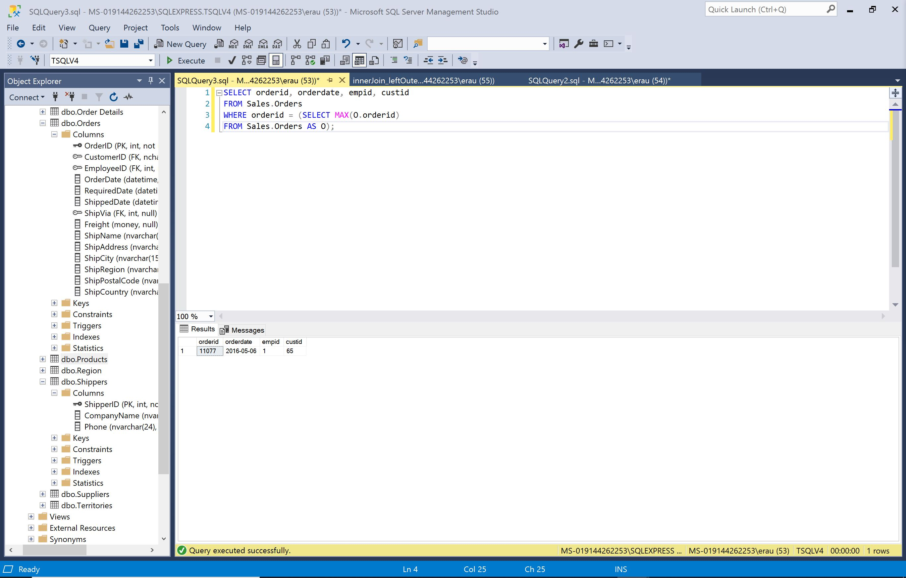

1. **Give an example of a subquery that returns multiple values. When would you use this kind of subquery?**

You would use this type of query when you need a specific set of information that might contain more than one value. You could also use this kind of subquery in lieu of a join. This query return all orders that were handled by employees with a last name starting with D.

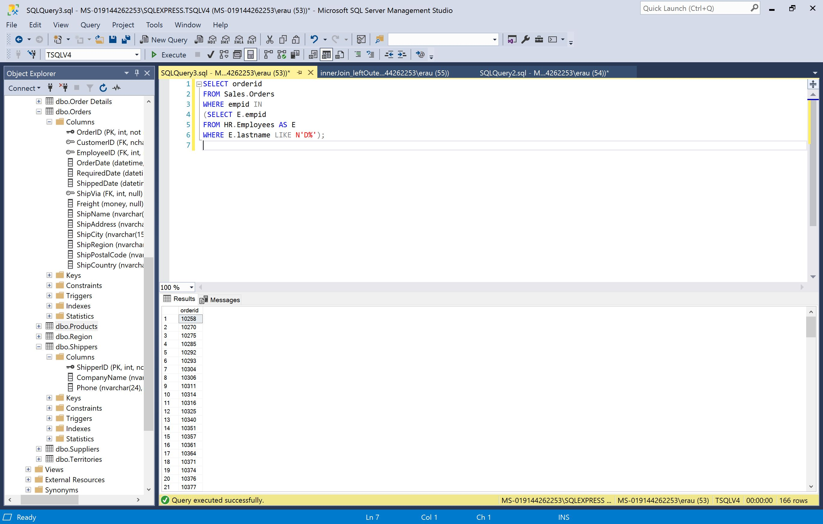

**\*See next page for Question 6\***

1. **Give an example of a subquery that returns table values. When would you use this kind of subquery?**

You would use this kind of subquery when you need associated values. This query returns table values with the maximum order ID for each customer.

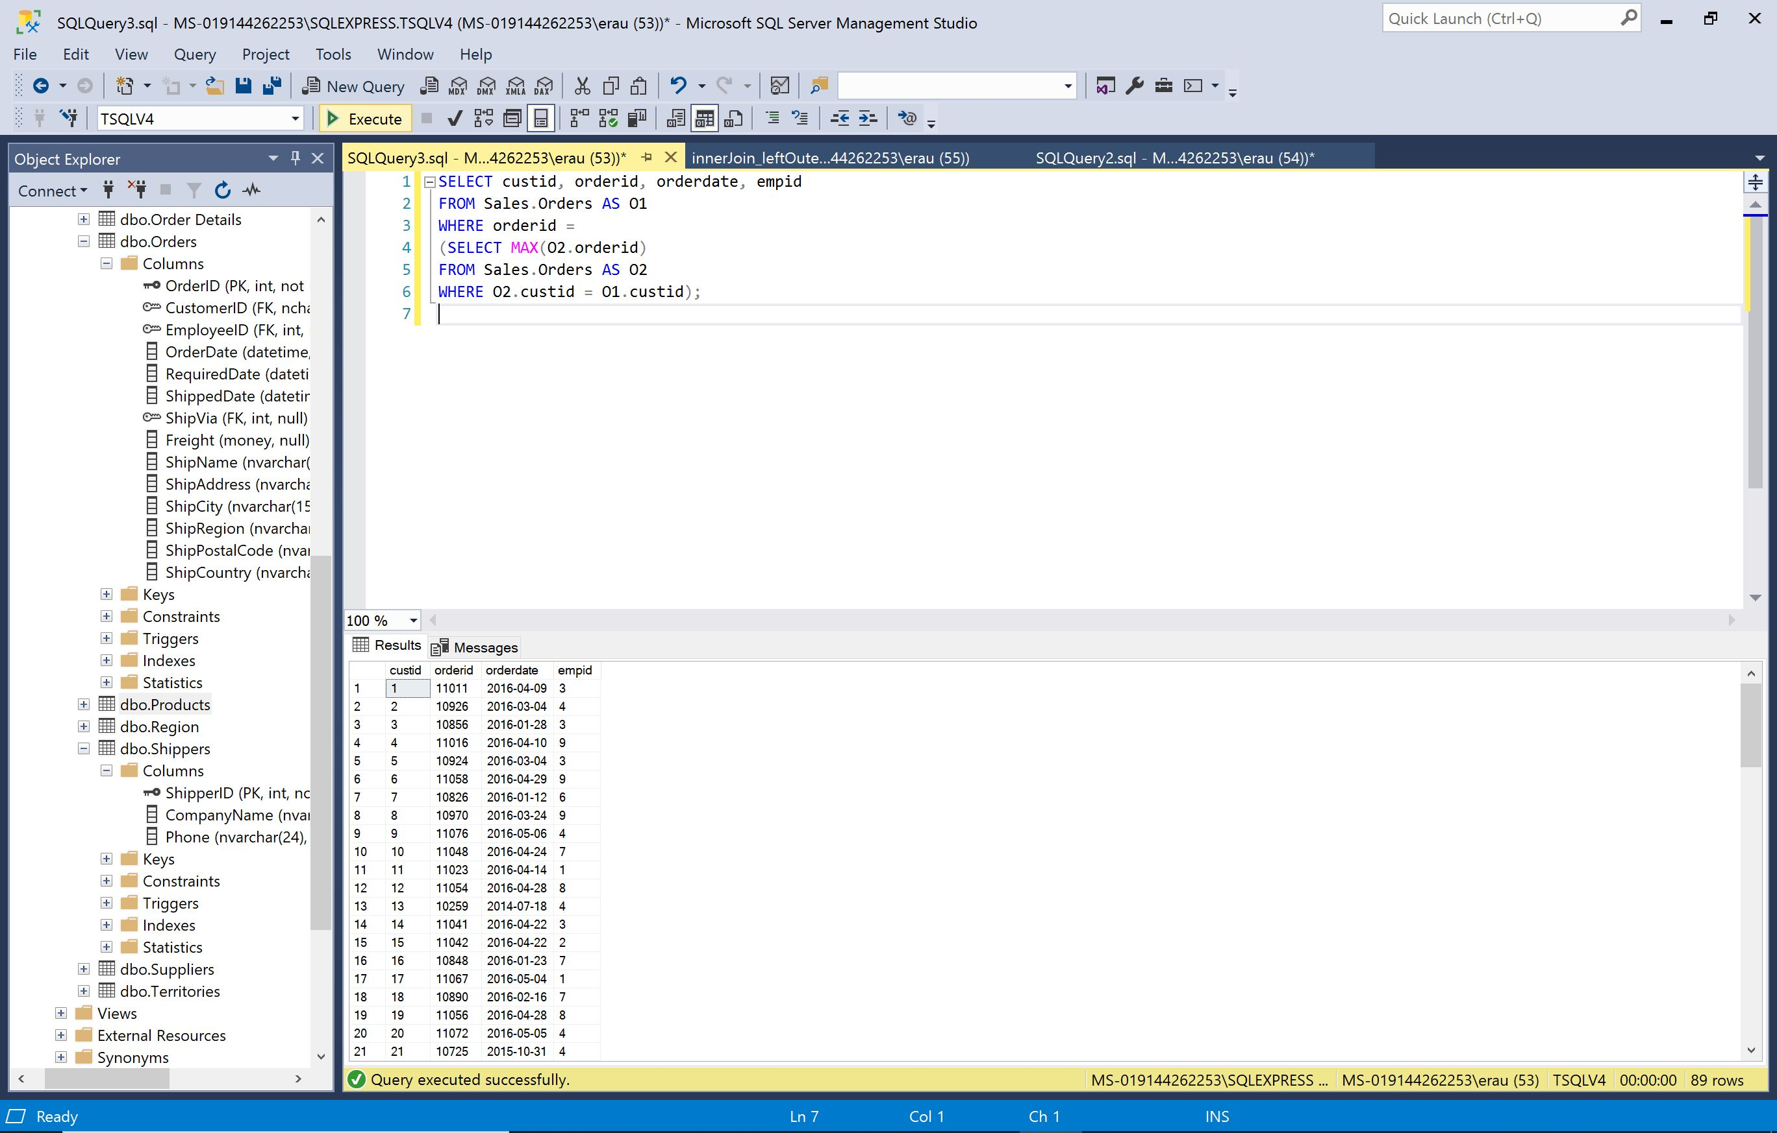

**\*See next page for Question 7\***

1. **What does the exists predicate do? Give an example.**

The EXISTS predicate accepts a subquery as input and returns TRUE if the subquery returns any rows and FALSE otherwise. In this example, the outer query against the Customers table filters only customers from Spain for whom the EXISTS returns TRUE.

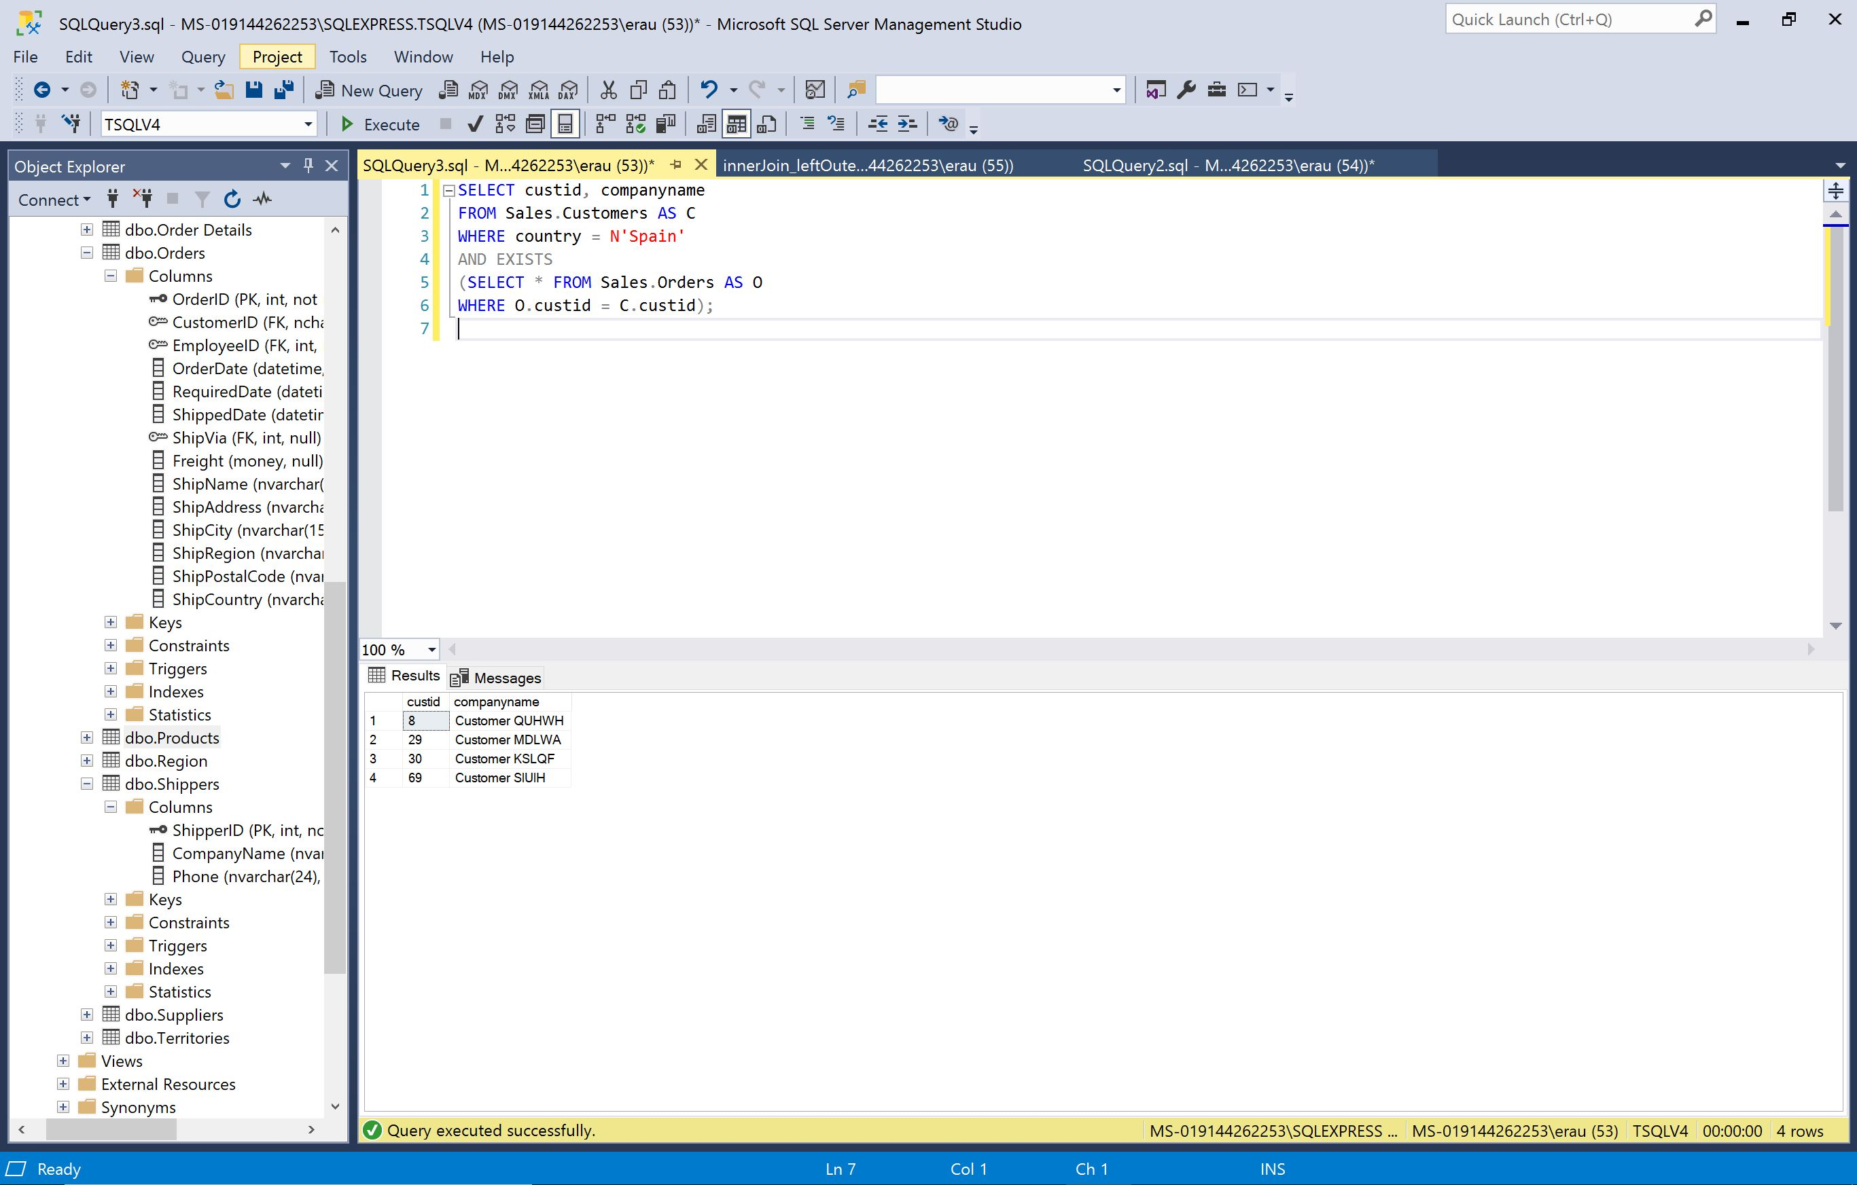

**\*See next page for Question 8\***

1. **What happens if we use the not operator before a predicate? Give an example.**

Using the NOT operator returns the opposite results of the predicate. This query returns customers from Spain who did not place orders.

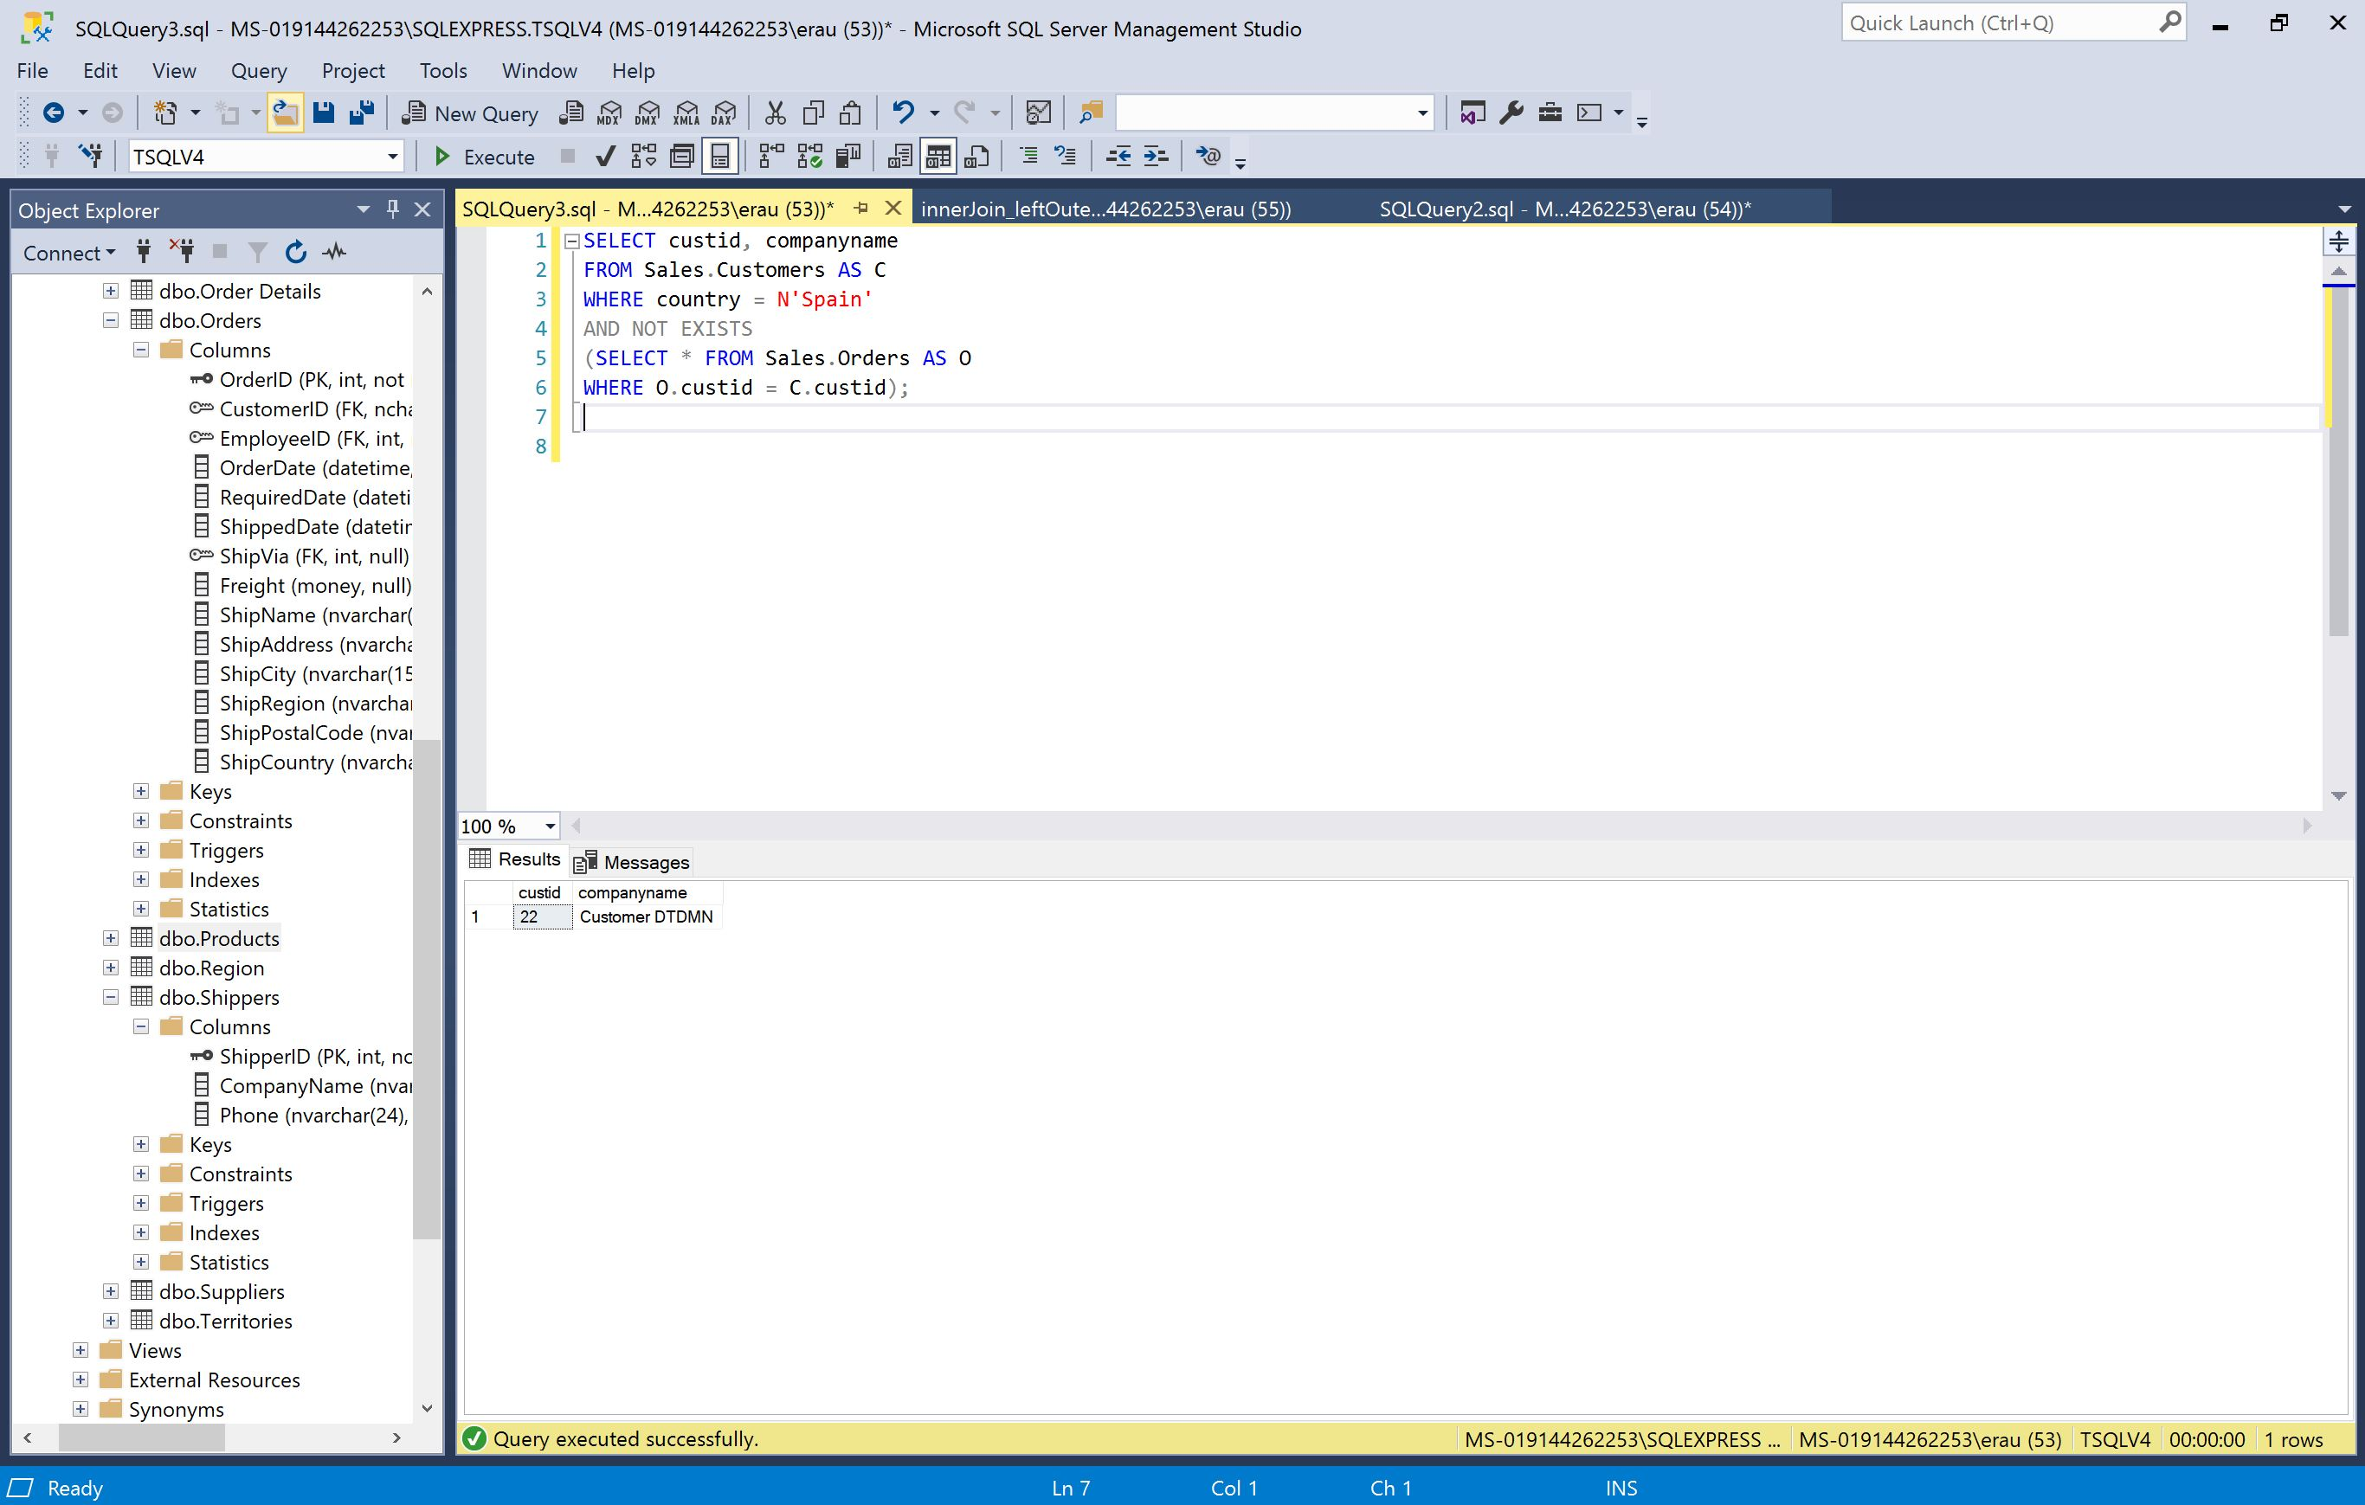

1. **When you use exists or not exists with respect to a row in a database, does it return two or three values? Explain your answer.**

It returns two values. EXISTS uses two-valued predicate logic it always returns TRUE or FALSE andnever UNKNOWN.

1. **How would you a subquery to calculate aggregates? For example, you want to calculate yearly sales of a product, and you also want to keep a running sum of total sales. Explain how you would use a subquery to do this.**

I would create an outer query that returned for each year the current year and quantity. Then I would use a correlated subquery to calculate the running-total quantity. The subquery should filter all rows where the order year is smaller than or equal to the current year in the outer query, and sum the quantities from the inner query.